**MySQL + Info-Gathering:**

**CMF - MySQL Server Info-Gathering Automation for Linux - User Guide**

**For Script:**

**CMF-MySQL-Linux.ps1**



**Document Summary**

|  |  |
| --- | --- |
| **Document Item** | **Current Value** |
| Document Title | MySQL Server Automation User Guide |
| Program | CSU Migration Factory |
| Date Last Modified | 05-Oct-2023 |
| Date Last Reviewed | 05-Oct-2023 |
| Current Document Known Issue | N/A |
| Status | Initial |
| Document Description | This document provides the procedure/steps to execute the Automation script which gathers the MySQL server details. |

**Revision History**

This section represents the change history of the document. Revisions of the document must be tracked by identifying a new version number, the date it was modified, the person making the change, and the reason for the change.

|  |  |  |  |  |
| --- | --- | --- | --- | --- |
| Date | Version | Change Description | Author | Reviewer |
| 5-Oct-2023 | 1.0 | Initial Version | Lekshmy, Arun, Mukesh, Chethan | Rackimuthu Kandaswamy |
| 04-Dec-2023 | 1.1 | Added SSL Mode | Lekshmy, Arun, Mukesh, Chethan | Sharad Khadtare,  Rackimuthu Kandaswamy |

Contents

Executive Summary 3

1.1 Objective 3

1.2 Recommendations 4

2 Prerequisites for MySQL Server Automation - Execution. 4

Non-Mission-Critical system 4

2.1 Input Excel File 4

2.2 PowerShell Installation on Linux 6

3 Copying Script 6

3.1 Folder Name 6

3.2 Script and Input file 7

4 Executing the Script 7

4.1 MySQL Server Automation execution 7

4.1.1 Create support folders(Logs, Output, Downloads etc) and Validate ImportExcel Module 8

4.2 Server List workbook in MySQL_Server_Automation_V1.0.xlsx 9

4.3 Automation Script Transcript Log 10

4.4 Final Output: 10

# Executive Summary

## Objective

This document provides the procedure/steps to execute the Automation script (CMF-MySQL-Linux.ps1) which gathers the MySQL Server details from Linux environment.

Note: The values present in the Screenshots are demo values. Please change the values as Appropriate.

## Recommendations

Key recommendations are as follows:

1. Run the script on Non-Mission-Critical systems ONLY (i.e.**NOT** on any production server)
2. Connectivity must exist between the SYSTEM which runs the MySQL Single Info Gathering Automation script
3. Powershell 5.1 version

# Prerequisites for MySQL Server Automation - Execution.

## Non-Mission-Critical system

* **Don't install and run the Automation scripts on any mission-critical production server.**

## Input Excel File

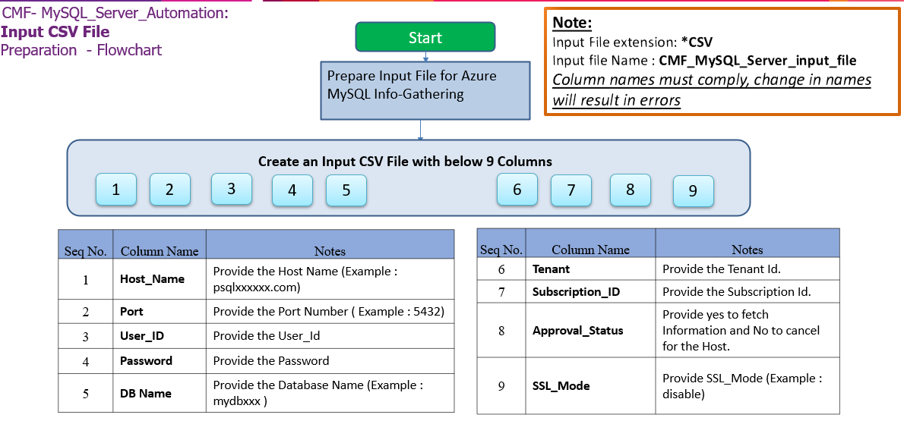

**Important Notes:**

* MySQL Client is required to establish Connectivity to MySQL Servers.
* This script is based on the CSV file named   
  ‘**CMF-MySQL_Server_Input_file.csv**’.
* **Column Name must be kept as shown below, change in names will result in errors**
* **Values in the column must be correct, incorrect values will also result in errors**
* **Tenant and Subscription_ID columns are Optional.**

1. **Columns for Input File: CMF-MySQL_Server_Input_file.csv**

|  |  |
| --- | --- |
| **Column Name** | **Note** |
| **Host_Name** | Provide the Host Name (Example : localhost) |
| **Port** | Provide the Port Number ( Example : 5432) |
| **VCore** | Provide the Number of VCore (Optional) |
| **Auth_Type** | Provide the Authentication Type(Optional) |
| **User_ID** | Provide the User_Id |
| **Password** | Provide the Password |
| **DB_Name** | Provide the Database Name (Example : postgres ) |
| **Tenant** | Provide the Tenant Id. (Optional) |
| **Subscription_ID** | Provide the Subscription Id. (Optional) |
| **Approval_Status** | Provide yes to fetch Information and No to cancel for the Host. |
| **SSL_Mode** | Provide SSL_Mode (Example : disable) |

|  |  |  |
| --- | --- | --- |
| **Seq.No** | **File** | **Note** |
| 1 |  | Sample: **CMF-MySQL_Server_Input_file.csv** |

## PowerShell Installation on Linux

|  |
| --- |
| # Register the Microsoft RedHat repository  curl https://packages.microsoft.com/config/rhel/7/prod.repo | sudo tee /etc/yum.repos.d/microsoft.repo  # Install PowerShell  sudo yum install –assume yes powershell  # Start PowerShell  Pwsh |

# Copying Script

## Folder Name

* Login into a Non-Mission-Critical system (i.e.**NOT**on any production server) from where the MySQL Server Automation is to be run
* Create a folder named MySQL.



## Script and Input file

* Copy the content under the folder created in the previous step.

## Renaming Scripts

* Execute the following command in Info-Gather folder to rename the scripts from .txt to .ps1

# Preparing the INPUT CSV File

In Order to support the Info Gathering process, INPUT CSV FILE (**CMF-MySQL_Server_Input_file.csv**) should be provided with PostgreSQL Server details.

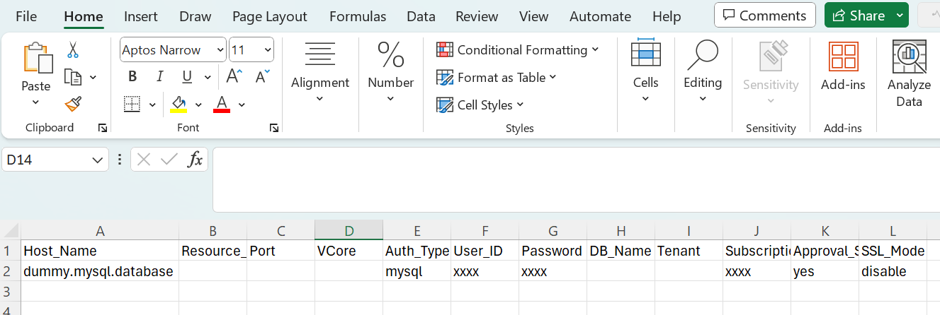

# Executing the Script

## MySQL Server Automation execution

* Open Putty, connect to the server and execute the script.

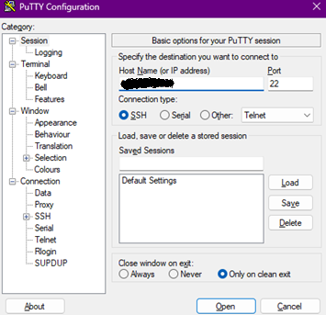

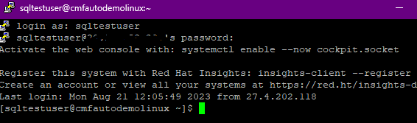

1. Enter the following command to execute the script.

**pwsh ./CMF-MySQL-Linux.ps1**

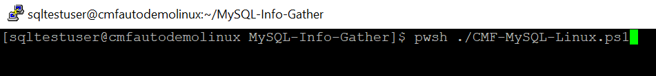

### Create support folders(Logs, Output, Downloads etc) and Validate ImportExcel Module

**Note:** After triggering the automation all the support folders (Logs, Output, Downloads etc.) will be created automatically by the automation script, Mysql path is validated, and it will ask user to proceed with the execution of the script.

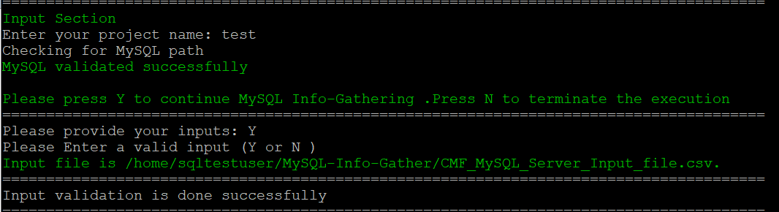

The script then Validates the list of Hosts to proceed with execution. Continue by Entering “Y” and provide your **Project Name**. You’ll get below Final Status of the Script Execution.

Note: Ensure you add the location of Mysql.exe to your Path environment variables

* List of the Hosts the automation will proceed based on the user selection.

* Next, enter “Y” to proceed MySQL server Info-Gathering.

* Final Execution

## Export Info-Gathering details and generating Output log files

Output log files are generated for each PostgreSQL Server as shown in the below Output Folder.

## Automation Script Transcript Log

**Note:** For the Automation, transcript will be generated in text format as above

(.\Logs\ CMF_MySQL_Server_Info_Gathering_Automation_Transcript_*.txt)